3/15/2025

Saqlain Mushtaq

Saqlain.mushtaqbalti@gmail.com

Open Ended Lab

Machine Learning

**THE UNIVERSITY OF AZAD JAMMU AND KASHMIR**



***Name: Saqlain Mushtaq***

***Roll No: 2022-SE-33***

***Course code: SE-3105***

***Course Title: Machine Learning***

***Semester: 5th***

***Session: 2022-2026***

***Submitted To: Engr. Muhammad Awais***

***Open Ended Lab***

**Department Of Software Engineering**

**Classification of MNIST Handwritten Digits using Logistic Regression, and Artificial Neural Networks:**

**Abstract:**This report presents a comparative study on the classification of MNIST handwritten digits using two different machine learning models: Logistic Regression, and Artificial Neural Networks (ANN). Initially, the models are trained using mnist_train.csv and tested on mnist_test.csv. Hyperparameter tuning is performed, after which mnist_train.csv is further split into training and testing sets for additional evaluation. Finally, the models' performances are compared to using accuracy metrics and confusion matrices.

**Notebook source:**The complete implementation of this study, including data preprocessing, model training, hyperparameter tuning, and performance evaluation, is available in the Jupyter Notebook:

  

**Introduction:**The dataset used in this project is the MNIST dataset, a benchmark dataset in machine learning and computer vision. It consists of 28x28 grayscale images of handwritten digits (0-9). The dataset is divided into a training set (mnist_train.csv) and a test set (mnist_test.csv).

**Two different classification models are implemented and evaluated:**

**Artificial Neural Network (ANN):** A deep learning approach using TensorFlow/Keras.

**Logistic Regression:** A traditional machine learning model using Scikit-Learn.

The goal is to compare their performance in recognizing handwritten digits.

**Methodology:**

**Dataset Preparation**

The training dataset (mnist_train.csv) and test dataset (mnist_test.csv) are loaded.

Features (pixel values) and labels (digit classes) are separated.

Pixel values are normalized (0-255 scaled to 0-1) for faster convergence.

In ANN, labels are one-hot encoded (required for categorical classification).

**Load Training and Test Data**

**Load the dataset for processing.**



**First few da**ta: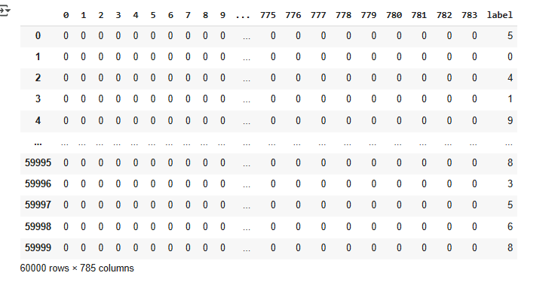

**Model 1: Artificial Neural Network (ANN)**

**Architecture:**

Input Layer: 784 neurons (for 28x28 image pixels).

**Hidden Layers:**

128 neurons (ReLU activation) + Dropout (0.2)

64 neurons (ReLU activation) + Dropout (0.2)

Output Layer: 10 neurons (Softmax activation) for classification into 10 digits.

**Optimization & Loss:**

**Optimizer:** Adam

**Loss function:** Categorical Crossentropy

**Metrics:** Accuracy

**Training:**

**Epochs:** 20

**Batch size:** 128

**Validation split:** 20% of training data

**Evaluation:** Accuracy is computed on a validation set.

**Model 2: Logistic Regression (One-vs-All)**

Binary classification per digit (0-9) using One-vs-All strategy.

**Feature Scaling:** Standardized using StandardScaler ().

**Solver:** lbfgs, **Max Iterations**: 500, **Tolerance:** 0.01.

**Predictions:** Probability scores from all 10 classifiers are used to select the most likely digit.

**Results:**

**ANN Performance**

Metric Value

**Validation Accuracy 97.55%**

**Test Accuracy 97.31%**

Loss and Accuracy over Epochs

Accuracy improved steadily over 20 epochs.

Loss decreased over time, showing good convergence.

**Confusion Matrix & Classification Report**

High accuracy across all digits.

Minor misclassifications occurred between similar digits (e.g., 3 and 5).

**Confusion Matrix**

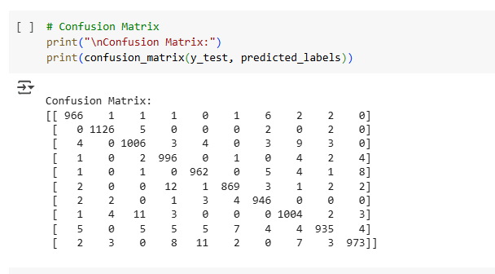

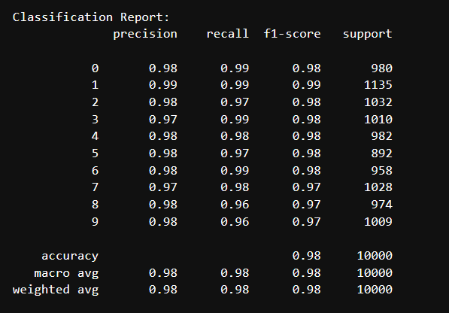**Classification Report:**

**Logistic Regression Performance**

**Metric Value**

Overall Test Accuracy  **0.8889%**

Accuracy of Individual Binary Classifiers (One-vs-All Approach)

**Digit Accuracy**

Accuracy for digit 0: 0.9871

Accuracy for digit 1: 0.9884

Accuracy for digit 2: 0.9742

Accuracy for digit 3: 0.9730

Accuracy for digit 4: 0.9774

Accuracy for digit 5: 0.9672

Accuracy for digit 6: 0.9837

Accuracy for digit 7: 0.9739

Accuracy for digit 8: 0.9595

Accuracy for digit 9: 0.9611

**Confusion Matrix**

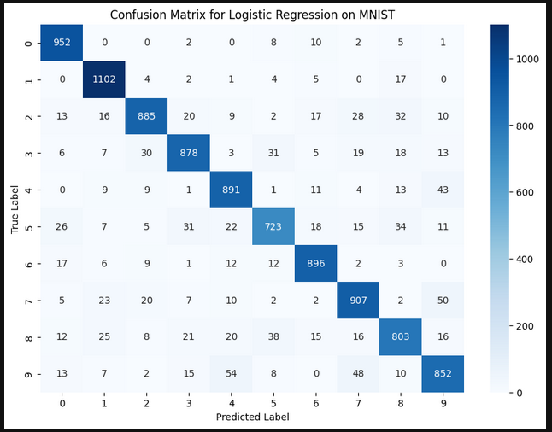Shows frequent misclassifications between similar-looking digits like 4 & 9, 3 & 5.

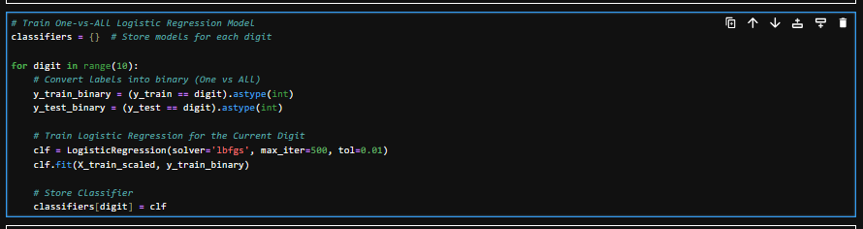

**Discussion:**

**Which Model Performed Best and Why?**

ANN outperformed Logistic Regression, achieving **97.31%** test accuracy compared to **0.8889%.**

ANN benefits from hidden layers, allowing it to capture more complex patterns in handwritten digits.

Logistic Regression relies on linear decision boundaries, which limits its ability to distinguish similar digits.

**Why did ANN perform better:**

**Non-linearity:** ReLU activation enables learning complex features.

**Dropout layers:** Prevent overfitting.

**More expressive power:** Unlike logistic regression, ANN captures spatial relationships in pixel data.

**Conclusion:**

Both models successfully classified handwritten digits, but ANN significantly outperformed Logistic Regression.

ANN achieved **97.31%** accuracy, demonstrating its superiority for image-based classification tasks.

Logistic Regression, while simpler and interpretable, struggles with complex patterns, achieving **0.8889%** accuracy.

**<><><><><><><><><><><><>THE END<><><><><><><><><><><><>**